HOME LEARNING PACK TERM 5 WEEK 1
THEME – COMMUNITY HELPERS
STEAM
TOPIC

This week your child will learn about community helper ‘Doctor’. While performing activity, it is crucial to emphasise on vocabulary and essential questions, such as ‘What does the doctor do?’, ‘Where do doctors work?’, ‘What do doctors use to cure us?’.
Page 1 – Puppet. Cut and glue all the parts in the correct place to make a doctor puppet.
Page 2- Doctor Bag. Cut all pictures and help your child build a doctor bag, glue all tools pictures inside the bag, revise topic vocabulary while making the ‘doctor bag’
Page 3- Vocabulary.
ROLE PLAY
Imaginative Role Play is an important part of early childhood development. As children engage in imaginative and dramatic play, they are developing a range of skills, including oral language, cooperation and problem solving.

DOCTOR IMAGINATIVE ROLE PLAY
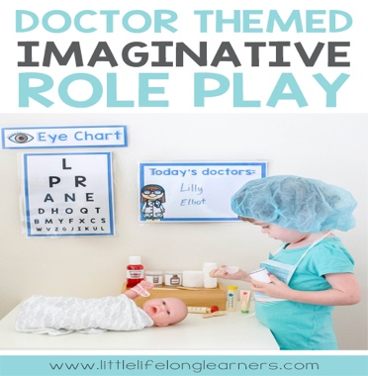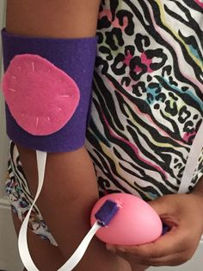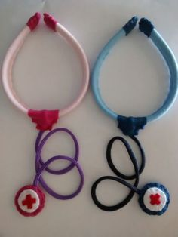
Set up a corner for your child to role-play using a small table, shelves, plastic containers, a doll, plasters, notebook, toy doctor kit if available or build your own as part of an art and craft activity (see above images). Encourage your child to act and pretend being a doctor. Remember essential questions, vocabulary and to make it FUN.

MUSIC
‘What do you do?’ song click link below
https://youtu.be/ckKQclquAXU
Key words: Teacher, Doctor, Dentist, Carpenter, Pilot.
Play the song a few times to help your child learn key words, then play the song again and keep pausing to encourage your child say key words independently. Incorporate role play resources as much as possible.
SENSORY ACTIVITY
SLIME
Follow instructions provided, involve your child in the process as much as possible, allowing her/him to learn how to follow instructions, sequence steps and experience different textures by adding glitter, small foam balls or simply rice grains, lentils that are in everyone’s kitchen, add food colouring to create different shades. Discuss the process, colour changes, soft or rough, sticky,….

MATH
Page 1- Numbers Matching Game. Cut and paste to count to 15.
Page 2- Join the numbers in the correct order to complete the picture. WHO IS IT?
Page 3- Colour the shapes following the key below:
Key: Square (different shades), Triangle, Circle, Rectangle
Shapes/Colours activities can also be used as Arabic Math activity, learning Math Arabic vocabulary.
PE
Pg 1- Cut and glue edges to build a dice. Allow glue to dry. Roll the dice and ask your child to
perform the action.
Activity 2: Click on the link below and encourage your child to exercise:
https://youtu.be/nD_f5oEUGgg
LITERACY
This week children will revise Jolly Phonics Group 1. For Jolly Phonics songs please click on the link below:
https://youtu.be/T4IfiKiQ-3I
Encourage your child to sound the letter while tracing or writing. Remember letters are always written from top to bottom. Revise vocabulary, things that begin with letters/sounds group 1 and 2. Practise sounding letters and blending sounds as first step to read words.
Page 1 - Writing and reading activity PDF Jolly Phonics Group 1.
Page 2 – Writing and Reading activity PDF Jolly Phonics Group 2
ARABIC
Page 1- Literacy. Trace and colour letter ‘Tha’
Page 2- Literacy Find and colour letter ‘Tha’.
Page 3- Math. Colour the gumballs that match the number written on the vending machine.

Please click links below to help your child learn the Arabic Alphabet and Numbers
Arabic Numbers song:
https://youtu.be/-4D2OWgqc3U

Video Numbers
https://youtu.be/NezLpsU_fTw
Alphabet song
https://youtu.be/5yO433hdR2M
HAVE A WONDERFUL TIME!

