HOME LEARNING PACK TERM 5 WEEK 1
THEME – COMMUNITY HELPERS
STEAM
TOPIC

This week your child will learn about community helper ‘Doctor’. While performing activity, it is crucial to emphasise on vocabulary and essential questions, such as ‘What does the doctor do?’, ‘Where do doctors work?’, ‘What do doctors use to cure us?’.
Page 1 – Puzzle. Cut, mix and let your child put pieces back correctly.
Page 2- Doctor Bag. Cut all pictures and help your child build a doctor bag, glue all tools pictures inside the bag, revise topic vocabulary while making the ‘doctor bag’
Page 3- Vocabulary.
ROLE PLAY
Imaginative Role Play is an important part of early childhood development. As children engage in imaginative and dramatic play, they are developing a range of skills, including oral language, cooperation and problem solving.

DOCTOR IMAGINATIVE ROLE PLAY
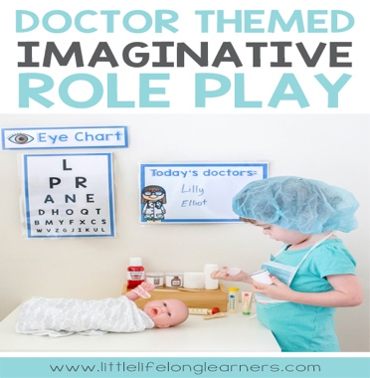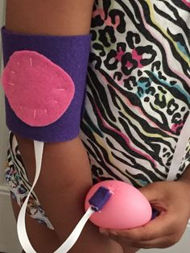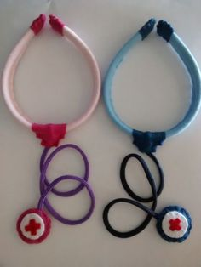

Set up a corner for your child to role-play using a small table, shelves, plastic containers, a doll, plasters, notebook, toy doctor kit if available or build your own as part of an art and craft activity (see above images). Encourage your child to act and pretend being a doctor. Remember essential questions, vocabulary and to make it FUN.

MUSIC
‘What do you do?’ song click link below
https://youtu.be/ckKQclquAXU
Key words: Teacher, Doctor, Dentist, Carpenter, Pilot.
Play the song a few times to help your child learn key words, then play the song again and keep pausing to allow your child say key words. Incorporate role play resources as much as possible.
MATH
Page 1- Numbers PDF.
Using playdough ask your child to form the number, make small balls and place them on the squares to match the number correctly.
Page 2-Shape/Colours.
Using paint ask your child to use his/her fingerprint to trace the shape line.
Colour Key: Circle, Square, Triangle
SENSORY ACTIVITY
SLIME
Follow instructions provided, involve your child in the process as much as possible, allowing her/him to learn how to follow instructions, sequence steps and experience different textures by adding glitter, small foam balls or simply rice grains, lentils that are in everyone’s kitchen; add food colouring and discuss colour changes, soft or rough, sticky, etc…
PE
Pg 1- Cut and glue edges to build a dice. Allow glue to dry. Roll the dice and ask your child to
perform the action.
Activity 2: Click on the link below and encourage your child to exercise:
https://youtu.be/nD_f5oEUGgg
LITERACY
Revision - Jolly Phonics Group 1. For Jolly Phonics songs please click on the link below:
https://youtu.be/T4IfiKiQ-3I

Page 1 -6- Encourage your child to sound the letter while colouring the picture, ask him/her to put his finger up in the air and pretend writing the letter. Remember to write letter from top to bottom.
Page 1- Letter/sound ‘s’
Page 2- Letter/sound ‘a’
Page 3- Letter/sound ‘t’
Page 4- Letter/sound ‘i’
Page 5- Letter/sound ‘p’
Page 6- Letter/sound ‘n’
Page 7- Match Letter/sound to the correct picture.

ARABIC
Page 1- Trace and colour letter ‘Ba’
Page 2- Find and colour letter ‘Ba’.
Page 3- Match the number to the correct picture.

Please click links below to help your child learn the Arabic Alphabet and Numbers
Arabic Numbers song:
https://youtu.be/-4D2OWgqc3U

Video Numbers
https://youtu.be/NezLpsU_fTw
Alphabet song
https://youtu.be/5yO433hdR2M
HAVE A WONDERFUL TIME!

